# Topic: A personalized travel and tracking app

# 

# Team members

SARATHI.M -812022104168

PUGAZHENDHI.S-812022104059

SHEIK VASEER.S-812022104072

**Description** :

# TravelMate is an all-in-one travel and tracking app designed to make your journeys smarter, easier, and more enjoyable. Whether you're traveling for business or pleasure, our app offers a personalized experience, helping you plan, track, and discover with ease.

Key Features:

1. Personalized Itinerary Management:

- Automatically syncs with your travel bookings (flights, hotels, tours, etc.).

- Creates a customized itinerary based on your preferences, interests, and travel history.

- Includes real-time updates and reminders for each leg of your trip (flight delays, gate changes, check-in times).

2. Smart Travel Assistant:

- AI-powered recommendations for things to do, places to visit, and restaurants tailored to your tastes and location.

- Get suggestions based on your past trips, current location, and local trends.

- Voice assistant to help with quick queries, such as directions, weather updates, or local attractions.

3. Live Trip Tracking & Notifications:

- Track the status of your flights, trains, buses, and other transportation modes in real-time.

- Receive automatic updates on delays, cancellations, gate changes, or alternate routes.

- Set up travel alerts for important events like weather changes or strikes that may impact your journey.

4. Expense & Budget Tracker:

- Record your travel expenses and stay within your budget with detailed tracking.

- Automatically categorize your spending (e.g., transportation, food, accommodation) and provide insights on where you’re overspending.

- Currency conversion and local price guides to avoid surprises.

5. Interactive Maps & Navigation:

- Get access to detailed, offline maps of your destinations, including points of interest, hidden gems, and suggested routes.

- Real-time GPS navigation for walking, driving, or public transportation.

- Augmented reality mode to explore landmarks and attractions with visual guides.

6. Safety Features:

- Emergency contact and local hospital information for peace of mind during your travels.

- Real-time location sharing with friends or family for safety purposes.

- Alerts on local weather, security incidents, and health warnings.

7. Custom Travel Goals & Milestones:

- Set personal travel goals, such as visiting a certain number of countries or landmarks, and track your progress.

- Earn badges or rewards for reaching milestones, like attending a local festival or completing a city walking tour.

8. Social Travel Network:

- Share your journey with friends or fellow travelers via photo albums, stories, or travel blogs within the app.

- Connect with a community of like-minded travelers for tips, recommendations, and shared experiences.

9. Sustainability & Responsible Travel:

- Get suggestions for eco-friendly accommodation, activities, and transportation.

- Track your carbon footprint and explore ways to make your travels more sustainable.

10. Seamless Integration with Other Apps:

- Sync with calendar, email, and social media accounts to streamline trip planning.

- Share itineraries, maps, and updates with others via messaging app

Why Choose TravelMate?

- Efficiency: With all your travel details in one app, you can spend less time organizing and more time exploring.

- Personalization: Enjoy a tailored experience that adapts to your unique travel style.

- Convenienc: From tracking your flight status to discovering local hotspots, everything you need is just a tap away.

- Peace of Mind: Stay safe and informed with real-time updates, emergency info, and health and safety alerts.

Who Should Use TravelMate?

- Frequent travelers seeking to streamline their trips.

- Solo travelers looking for local recommendations and safety features.

- Families wanting a reliable way to track all travel details.

- Adventure seekers searching for personalized experiences and off-the-beaten-path attractions.

- Business traveler needing efficient itinerary management and real-time tracking.

TravelMate ensures that your travel experience is smooth, personalized, and stress-free—no matter where you go.

Program:

import android.content.Context

import android.content.Intent

import android.os.Bundle

import androidx.activity.ComponentActivity

import androidx.activity.compose.setContent

import androidx.compose.foundation.Image

import androidx.compose.foundation.background

import androidx.compose.foundation.layout.*

import androidx.compose.material.*

import androidx.compose.runtime.*

import androidx.compose.ui.Alignment

import androidx.compose.ui.Modifier

import androidx.compose.ui.graphics.Color

import androidx.compose.ui.layout.ContentScale

import androidx.compose.ui.res.painterResource

import androidx.compose.ui.text.font.FontFamily

import androidx.compose.ui.text.font.FontWeight

import androidx.compose.ui.text.input.PasswordVisualTransformation

import androidx.compose.ui.tooling.preview.Preview

import androidx.compose.ui.unit.dp

import androidx.compose.ui.unit.sp

import androidx.core.content.ContextCompat

class LoginActivity : ComponentActivity() {

private lateinit var databaseHelper: UserDatabaseHelper

override fun onCreate(savedInstanceState: Bundle?) {

super.onCreate(savedInstanceState)

databaseHelper = UserDatabaseHelper(this)

setContent {

LoginScreen(this, databaseHelper)

}

}

}

@Composable

fun LoginScreen(context: Context, databaseHelper: UserDatabaseHelper) {

var username by remember { mutableStateOf("") }

var password by remember { mutableStateOf("") }

var error by remember { mutableStateOf("") }

Column(

modifier = Modifier.fillMaxSize().background(Color.White),

horizontalAlignment = Alignment.CenterHorizontally,

verticalArrangement = Arrangement.Center

) {

Image(painterResource(id = R.drawable.trav), contentDescription = "")

Text(

fontSize = 36.sp,

fontWeight = FontWeight.ExtraBold,

fontFamily = FontFamily.Cursive,

text = "Login"

)

Spacer(modifier = Modifier.height(10.dp))

TextField(

value = username,

onValueChange = { username = it },

label = { Text("Username") },

modifier = Modifier.padding(10.dp)

.width(280.dp)

)

TextField(

value = password,

onValueChange = { password = it },

label = { Text("Password") },

visualTransformation = PasswordVisualTransformation(),

modifier = Modifier.padding(10.dp)

.width(280.dp)

)

if (error.isNotEmpty()) {

Text(

text = error,

color = MaterialTheme.colors.error,

modifier = Modifier.padding(vertical = 16.dp)

)

}

Button(

onClick = {

if (username.isNotEmpty() && password.isNotEmpty()) {

val user = databaseHelper.getUserByUsername(username)

if (user != null && user.password == password) {

error = "Successfully log in"

context.startActivity(

Intent(

context,

MainActivity::class.java

)

)

//onLoginSuccess()

}

else {

error = "Invalid username or password"

}

} else {

error = "Please fill all fields"

}

},

modifier = Modifier.padding(top = 16.dp)

) {

Text(text = "Login")

}

Row {

TextButton(onClick = {context.startActivity(

Intent(

context,

.height(150.dp)

.scale(scaleX = 1.2F, scaleY = 1F)

)

Text(

Text = stringResource(id = R.string.place_2),

fontSize = 18.sp

)

Text(

Text = stringResource(id = R.string.description),

fontWeight = FontWeight.Light,

fontSize = 16.sp,

textAlign = TextAlign.Center,

)

Text(

Text = stringResource(id = R.string.plan), color = Color.Gray,

fontSize = 16.sp

)

}

}

Spacer(modifier = Modifier.height(20.dp))

//03

Card(

Modifier = Modifier

.fillMaxWidth()

.height(250.dp)

.clickable {

Context.startActivity(

Intent(context, SingaporeActivity::class.java)

)

},

Elevation = 8.dp

)

{

Column(

horizontalAlignment = Alignment.CenterHorizontally

) {

Image(

painterResource(id = R.drawable.singapore), contentDescription = “”,

modifier = Modifier

.height(150.dp)

.scale(scaleX = 1.2F, scaleY = 1F)

)

Text(

Text = stringResource(id = R.string.place_3),

fontSize = 18.sp

)

Text(

Text = stringResource(id = R.string.description),

fontWeight = FontWeight.Light,

fontSize = 16.sp,

textAlign = TextAlign.Center,

)

Text(

Text = stringResource(id = R.string.plan), color = Color.Gray,

fontSize = 16.sp

)

}

}

Spacer(modifier = Modifier.height(20.dp))

}

}

}

Package com.example.travelapp

Import android.content.Context

Import android.content.Intent

Import android.os.Bundle

Import androidx.activity.ComponentActivity

Import androidx.activity.compose.setContent

Import androidx.compose.foundation.Image

Import androidx.compose.foundation.clickable

Import androidx.compose.foundation.layout.*

Import androidx.compose.foundation.rememberScrollState

Import androidx.compose.foundation.verticalScroll

Import androidx.compose.material.Card

Import androidx.compose.material.Text

Import androidx.compose.runtime.Composable

Import androidx.compose.ui.Alignment

Import androidx.compose.ui.Modifier

Import androidx.compose.ui.draw.scale

Import androidx.compose.ui.graphics.Color

Import androidx.compose.ui.res.painterResource

Import androidx.compose.ui.res.stringResource

Import androidx.compose.ui.text.font.FontFamily

Import androidx.compose.ui.text.font.FontWeight

Import androidx.compose.ui.text.style.TextAlign

Import androidx.compose.ui.unit.dp

Import androidx.compose.ui.unit.sp

Class MainActivity : ComponentActivity() {

Override fun onCreate(savedInstanceState: Bundle?) {

Super.onCreate(savedInstanceState)

setContent {

TravelApp(this)

}

}

@Composable

Fun TravelApp(context: Context) {

Column(

Modifier = Modifier

.padding(20.dp)

.verticalScroll(rememberScrollState())

) {

Text(

fontSize = 40.sp,

color = Color(android.graphics.Color.rgb(120, 40, 251)),

fontFamily = FontFamily.Cursive,

text = “Wanderlust Travel”

)

Spacer(modifier = Modifier.height(20.dp))

// 01

Card(

Modifier = Modifier

.fillMaxWidth()

.height(250.dp)

.clickable {

Context.startActivity(

Intent(context, BaliActivity::class.java)

)

},

Elevation = 8.dp

)

{

Column(

horizontalAlignment = Alignment.CenterHorizontally

) {

Image(

painterResource(id = R.drawable.bali), contentDescription = “”,

modifier = Modifier

.height(150.dp)

.scale(scaleX = 1.2F, scaleY = 1F)

)

Text(

Text = stringResource(id = R.string.place_1),

fontSize = 18.sp

)

Text(

Text = stringResource(id = R.string.description),

fontWeight = FontWeight.Light,

fontSize = 16.sp,

textAlign = TextAlign.Center,

)

Text(

Text = stringResource(id = R.string.plan), color = Color.Gray,

fontSize = 16.sp

)

}

}

Spacer(modifier = Modifier.height(20.dp))

//02

Card(

Modifier = Modifier

.fillMaxWidth()

.height(250.dp)

.clickable {

Context.startActivity(

Intent(context, ParisActivity::class.java)

)

},

Elevation = 8.dp

)

{

Column(

horizontalAlignment = Alignment.CenterHorizontally

) {

Image(

painterResource(id = R.drawable.paris), contentDescription = “”,

modifier = Modifier

.height(150.dp)

.scale(scaleX = 1.2F, scaleY = 1F)

)

Text(

Text = stringResource(id = R.string.place_2),

fontSize = 18.sp

)

Text(

Text = stringResource(id = R.string.description),

fontWeight = FontWeight.Light,

fontSize = 16.sp,

textAlign = TextAlign.Center,

)

Text(

Text = stringResource(id = R.string.plan), color = Color.Gray,

fontSize = 16.sp

)

}

}

Spacer(modifier = Modifier.height(20.dp))

//03

Card(

Modifier = Modifier

.fillMaxWidth()

.height(250.dp)

.clickable {

Context.startActivity(

Intent(context, SingaporeActivity::class.java)

)

},

Elevation = 8.dp

)

{

Column(

horizontalAlignment = Alignment.CenterHorizontally

) {

Image(

painterResource(id = R.drawable.singapore), contentDescription = “”,

modifier = Modifier

.height(150.dp)

.scale(scaleX = 1.2F, scaleY = 1F)

)

Text(

Text = stringResource(id = R.string.place_3),

fontSize = 18.sp

)

Text(

Text = stringResource(id = R.string.description),

fontWeight = FontWeight.Light,

fontSize = 16.sp,

textAlign = TextAlign.Center,

)

Text(

Text = stringResource(id = R.string.plan), color = Color.Gray,

fontSize = 16.sp

)

}

}

Spacer(modifier = Modifier.height(20.dp))

}

}

}

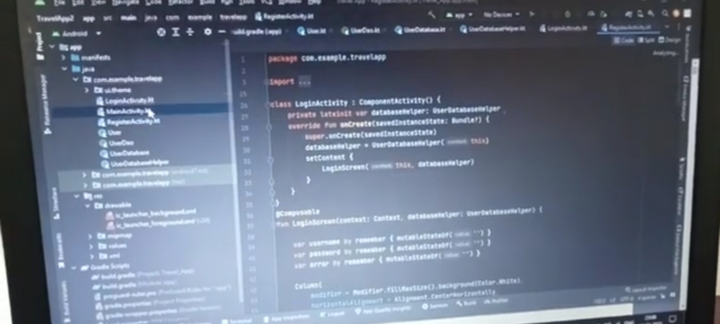**OUTPUT:** 